Inanga Spawning at Te Huauri o Te Kawa
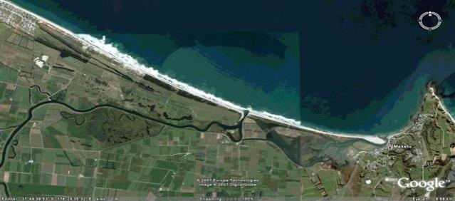
Te Huauri o Te Kawa (previously known as the By de Ley Wetland, aka The Borrow Pits) is approximately 2 km upriver from The Cut, on the true right side of the Kaituna River, in the Bay of Plenty. This is a wetland enhancement project aimed at providing rearing habitat for inanga, which is the species supplying the bulk of our whitebait catch.
Initiated by the Maketu Taiapure Trust, in 2002, the project has received considerable assistance from Te Arawa, Regional and District councils, and volunteer community labour. Many thanks to all and especially Henry and Maria By de Ley who have donated and covenanted their part of the land for this project.
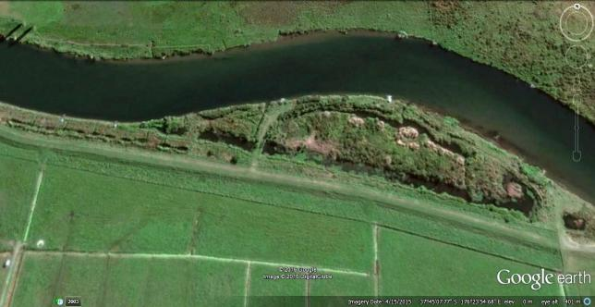

2016
Inanga spawning was observed on 12th March at two sites. The arrow in the middle of the above photo points to one of the main channels into the pond system (E2 channel) adjacent to where a side channel diverts to E2 Pond. This is the same area as spawning was recorded in 2014. This channel and its use as an inanga spawning area has been known for a long time. (Mitchell 1990)
More closely observed this month is the left-hand arrow. This arrow points to the channel between the river and NSP5 which is connected to NSP4 (New Small Pond).
As the name suggests, this is recently constructed habitat to provide a rearing kāinga for inanga (and other fish) and this is the first time that spawning has been observed here since the ponds were excavated in 2011.
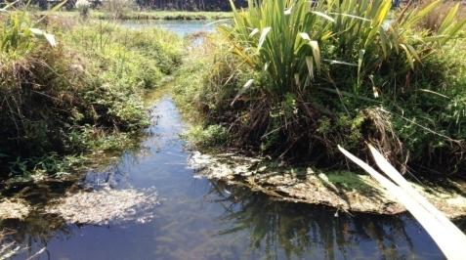
View looking from NSP5 out to river
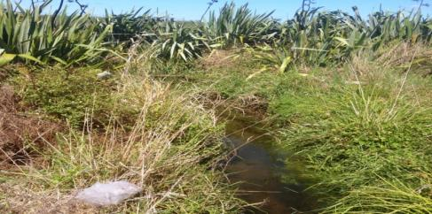
Looking from the river back to the pond
March 12th: high tide 1055 biggest tide for this new moon.
1200: spawning was already started, large and small groups of inanga were arriving from the river, flowing in ever-bigger groups backwards and forwards, between the river and the pond, a distance of about 20 metres.
At times groups of fish seemed to be “searching” the bank vegetation. Close to, but below the surface of the water, probing in and out before apparently deciding on the right place. Groups would disappear into the vegetation and “spattering” could be heard and the visible cloud of milt increased and expanded. Large and small groups flowed in and out of the areas until around 1230 when spawning ceased but groups of fish still flowed in and out of the channel and NSP5 & 4 ponds had big shoals roaming around. All fish observed post-spawning looked none the worse for the experience and none showed any likelihood of instant mortality.

March 13th: high tide 1147 day after biggest tide
1200, groups of fish were roaming the channel and probing the vegetation, from about
1230, spawning was constant
1300 spawning ceased but as the previous day, groups of fish continued to roam around 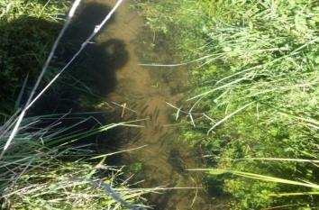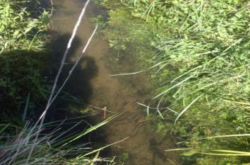
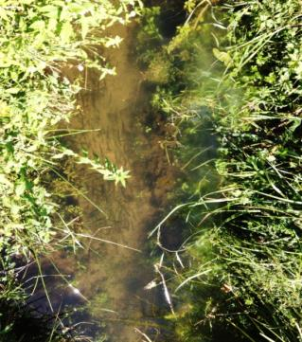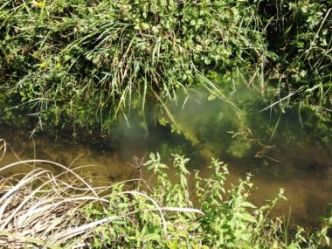
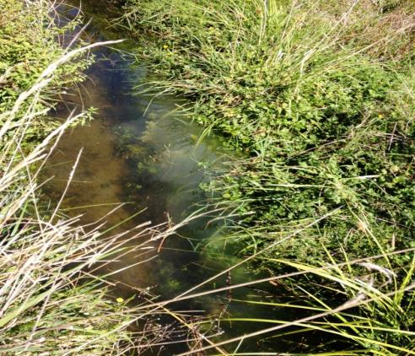
March 14^{th:} although there was a build-up of groups of inanga over the high tide, no spawning was observed.

April 2016
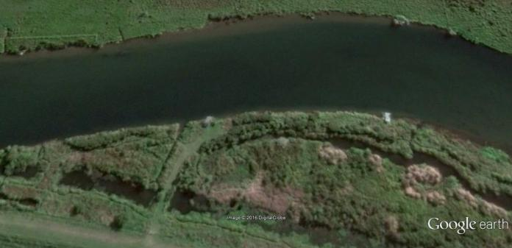
Bigger tides during dark than in daytime.
April 8th: Evening high tide 1926
No groups of fish visible, occasional individuals.
April 9th: high tide 0749 day before biggest tide
0800: Large shoals of inanga roaming both sides of E2 (Entry 2) channel, close to junction with channel to E2P (Entry 2 Pond). Eel seen hunting around fringes of bank vegetation. Good view of the area of activity from the bridge over the E2 channel overlooking the corner of E2 and E2P channel.
No sign of any activity in any of the NSP river channels.
0830: Ever bigger numbers of fish coming in from the river and roaming around the corner. Another eel was observed hunting around, not seen attacking any inanga. There were now many thousands of inanga, in large and small groups, roaming the edges of the vegetation, probing in, here and there, but mostly focused around the corner.
0915: Milt showing in both channels just above the corner. The spattering continued and the milt thickened. The spattering continues for a while after it seems that milt is no longer being produced but the milt hangs in a cloud, only very slowly dispersed by the outgoing current.
0945: Spawning finished.
1015: Still many groups of active fish roaming around the junction of the 2 channels

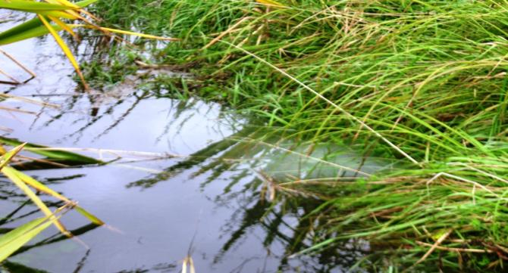
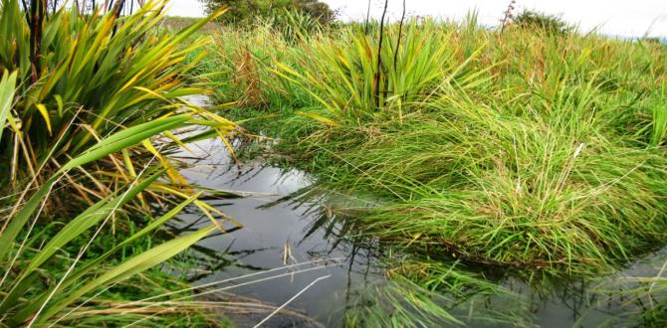
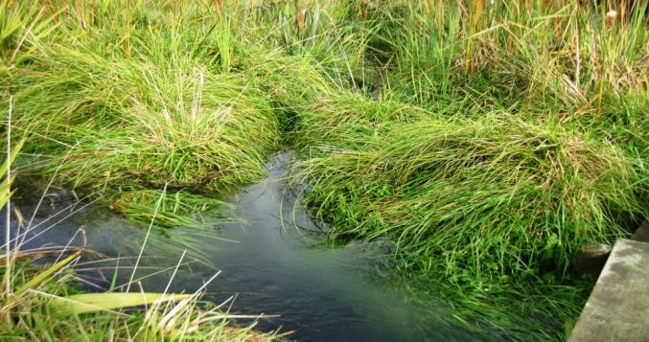
The spawning is happening immediately behind the tall fescue plant that forms the point of the juncture between the 2 channels. The milt flows out both sides, into both channels.

April 9th: evening high tide 2021
Very dark. Very different behaviour from the fish.
Over the top of the tide many (50-60) individual inanga sitting facing the incoming current, just brushing the tips of the bank-side vegetation on both sides of the E2 channel to just past the junction of the 2 channels. Very little change of position, almost like sentries. They did not seem to be disturbed by the light of my headlight.
When the flow changed to outwards they all turned around to face into the current but stayed where they were.
In the hour following the change of tidal flow, groups after groups of inanga poured into the E2 channel and then just disappeared into the darkness. No sign of spawning-type activity. At about the end of that hour fish ceased coming in from the river and then, over a period of about 10 minutes, gradually all the individual “sentries” or “pheromone dispensers” or whatever they were doing, all disappeared and no more fish seen.
April 10th: high tide 0841. Day of biggest tide (tonight at 2114)
0820: Big shoals arriving from river and merging with ever-bigger shoals roaming around the same junction of the 2 channels as the previous day. Not as many fish in total as previous day.
1000: Spawning happening in the same place as the previous day, though less of a milt cloud but still clearly visible. Though fewer fish spawning, they still carried on for most of half an hour. Also as in the previous day, groups of 200 – 500 fish roamed around the area for another half an hour or so, then disappeared. Several eels hunting around throughout.
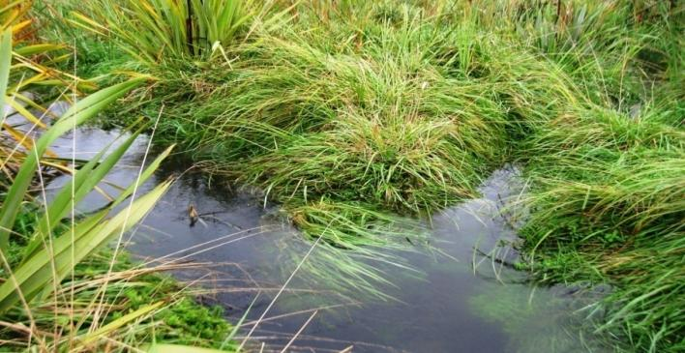

Salinity readings were taken just after spawning started, at the bridge over E2 channel and at the whitebait stand nearby, on the river.
At the river : on the surface .7 ppt, at the bottom of the river, 24.0 ppt (most of 4m cable).
In the E2 channel : on surface .4 ppt, at the bottom of the channel, 1.2 ppt. (about 1m deep)
April 11th: high tide 0934. Day after biggest tide.
0900: Some small shoals and an eel visible.
0910: A rat swam below me on the bridge, underwater it swam into the entrance to the E2P channel, surfaced right at the spawning site and disappeared into the vegetation.
0945: still slight incoming tide, much fewer, smaller groups of inanga roaming the same area as previous days. Several eels hunting the area.
1000: Outward flow, groups of fish probing into spawning site and circling around the area.
1110 – 1120: Spawning, just visible milt from same 2 places as previous, ie. Spawning still in the area immediately behind that tall fescue. Eel slurps could be heard back in the vegetation at the spawning site. They were not visible so not known whether they were feeding on the fish or the eggs.
As on previous days, groups of fish stayed around for about a half an hour. It was noticeable that more than half of the fish in these groups seemed to be juvenile/immature fish. Possibly this could be a part of why these fish come back to the same places to spawn year after year, because the juveniles have come to the spawning site and know where to come back to, next spawning time. (?)
April 12th: high tide 1027 2 days after biggest tide.
1025: A few small groups present and some coming in from river.
1055: small groups roaming, probing the vegetation
1200: Spawning, maybe only around 500 or so fish, spawning only lasted less than five minutes, only just discernible milt trail from same site as previous days. As spawning was happening 2 eels invaded the spawning site and could be seen to be very active, roiling around and slurping constantly. This carried on for about 3-4 minutes with the inanga pushing into the site and then scattering out and pushing back in, then flaring out again. Then the eels left and the fish continued to roam around as usual and again, seemed to be mainly immature fish.
1230: All fish gone.

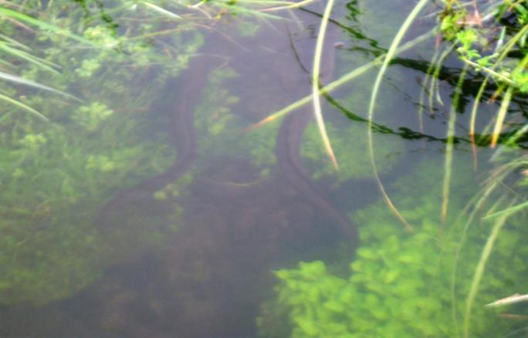
Two eels invade the spawning site.
So, with four slightly different tide levels across the four days that spawning occurred, a significant area was likely to have been covered with eggs but the arrival of the rat and the eels also graphically illustrate the perils the eggs face prior to hatching.
Will it happen again next month?
Yes it does but on a much smaller scale.
May 7th: high tide 0631 2 days before biggest tide.
0700: A few small groups roaming around, still in and out pulses of tidal flow in the channel.
0720: Bigger groups of several hundreds of fish roaming the area and in and out from spawning site to the river.
0750: Fish were gathering in grass at the base of the flax plant in from previous spawning site and were quite active there with some splattering but no visible milt.
0800: Spawning/spattering occurring at previous site at the tall fescue plant. Much smaller numbers than previous month, maybe around 1-1500 fish. Milt only just visible in the current.
As the previous spawnings, groups of fish, roamed around the site for about half an hour with groups dropping back to the river or into the ponds all that time until they were all gone.

May 8th: high tide 0726 Day before the biggest tide.
0800: A large shoal roaming around the spawning site. First one, then another, eel showed up. They mostly seem to be hunting the depths of the vegetation around the site rather than attacking the fish.
0840: Spawning/spattering for about 5minutes, barely perceptible milt stain in the water. Probably fewer than a thousand fish.
Groups of fish roamed around as usual but seemed to be localised on what might be perceived to be the scent trail from the spawning site. They stayed around a bit longer until about 0930. Gradually they all dropped back, in dribs and drabs, to the river.
May 9th: high tide 0819 Biggest high tide of the month.
0800: Several small shoals coming in from the river, joining other small shoals already at the spawning site.
0830: First outward movement of tide noticed. Coming up to the very top of the tide the water movement pulses in and out of the channels to and from the river. As this pulsing starts to get stronger both ways, in and out of the ponds, towards the very top of the tide, more and more fish come in from the river. Possibly because the outward pulses carry the scent/pheromones of the site and the already attendant fish, out to the fish arriving to that section of river. (?)
1000: Spawning first noticed, a faint trail of milt from usual tall fescue plant. This plant has collapsed a bit since last month’s spawning and the top of the plant is now level with the surface of the water as the fish are spawning and the fish could be seen around the top of the plant, right across the front of the plant. At a small hole into the vegetation inanga were clearly visible, vibrating in the water, splattering on the surface. Spawning lasted about ten minutes. As always, the eels were there for breakfast.
Again, a small spawning of maybe a thousand or so fish. Unusually, only a very few fish stayed around afterwards, dropping back to the river, they were all gone in a few minutes.
May 10th: high tide 0913 Day after biggest tide.
0845: A group of a hundred or so roaming around, small groups and individuals coming in from river.
0912: First outward tide movement, a few small groups of fish roaming around and some individuals still arriving from the river, maybe a couple of hundred fish in all.
1030: Around expected spawning time, still not much more than a couple of hundred fish, in usual spawning activity mode, roaming around the spawning site, probing into the vegetation but nothing happened. No visible milt, no spattering heard, they continued the activity for about half an hour and then mostly dropped away back to the river.
No eels turned up.
June 7th: high tide 0758 Biggest tide
0730: Already a steady outward flow from the ponds to the river. Much more secretive activity, no fish visible in the main channel at the juncture as previously but large groups back in the channel to E2P, further in from the previous spawning site and much more in the overhanging vegetation, with considerably reduced visibility.
0750: Some groups of several hundred fish becoming very active along both sides of the channel. Two points on one side and one on the other seemed to be points of focus.
0800: Spattering could be heard back in the vegetation at those three points though the milt was barely perceptible and the spattering lasted for less than ten minutes. As always, several eels were hunting throughout.
Different to the previous spawning, this time it was on the rising to the top of the tide that spawning occurred.
As the tide neared the top, an eel could be heard slurping in the previous spawning site. Maybe feeding on the larvae hatching out from the previous month’s spawning?
June 8th: high tide 0851 Day after biggest tide.
0815: About the same numbers of fish and a similar level of activity in the same area, as the previous day.
0830: Spawning pretty much a repeat of the previous day in the same three spots for about the same length of time. Again, spawning occurred as the tide was rising to the top.
July: No spawning behaviour observed over 2 days of highest tides.
August: Was not there for biggest tides.
September 19th: high tide 0811 Today and tomorrow equally, biggest tides for the month.
0900: Strong tidal flow out of the channel, several small groups of inanga roaming around the previous spawning site in typical pre-spawning behaviour. Groups kept enlarging to a total of a few hundred fish.
0910-20: An almost standard indicator by now, an eel probing the spawning site, was there a spawning yesterday? Inanga kept flaring away from the eel but still wanted to get back into the spawning site. After the eel left, the inanga crowded more densely into the site.
Roamed around as usual for about 15 minutes, and then they were all gone. Another bigger eel turned up, scouted around the site then disappeared.
October 19th: high tide 0945 biggest tide
1030: several small groups (50-60) displaying spawning behaviour around the area at E2 channel. No spawning observed but it was very likely to have occurred unseen.
November 16th: high tide 0833 day before biggest tide
0900: still incoming, ankle-deep over bridge, super moon – super tides.
0945: No inanga spawning behaviour observed.
November 17th: high tide 0927 biggest tide
1045: No inanga spawning behaviour observed.
November 18th: high tide 1021 day after biggest tide
1030 – 1045: 3 good-sized shoals of whitebait entered the channel and headed into the ponds, then one shoal came back out – didn’t like the hood around there? Plenty of juvenile inanga feeding in the delta of the channel where it joins with the river.
No inanga spawning behaviour observed.
December 15th: high tide 0816 day before biggest tides
0930: No inanga spawning behaviour observed.
December 16th: high tide 0909 equal biggest tide with tomorrow
0950: shoal of whitebait travelling in channel into ponds.
No inanga spawning behaviour observed.
December 17th: high tide 1002 equal biggest tide with yesterday
1100: no inanga spawning behaviour observed but plenty of other activity – whitebait and juvenile inanga feeding in the channel current and a shoal of about 60 juvenile yellow eyed mullet (YEMs) (70-100mm) feeding over the rocks on the bottom of the channel. They stayed separate from the usual toing and froing of the adults in and out of the channel.

2017
January 14th: high tide 0851 day before biggest tide
0900: Tide slowed incoming to stop
0905: Strong outward flow.
0930: Plenty of groups of developing inanga feeding in the current in the channel. From just coloured whitebait up to about half-grown size, very few full-grown adults seen
1000: YEMs toing and froing. No aggregating/spawning behaviour seen.
January 15th: high tide 0941 biggest tide
Same as yesterday.
January 16th: high tide 1030 day after biggest tide Same as yesterday and the day before.
February 13th: high tide 0919 biggest tide
Same as last month, plenty of fish activity but no inanga spawning behaviour observed. Over the last hour of the incoming tidal flow and across the high tide, fish activity very dense across the delta of the E2 channel and the main stem of the river. A shallow delta leads out to a steep drop-off into the river which is about 4m deep. Several shoals of inanga feeding off the edge of the drop-off, into the incoming tidal flow, with groups dropping back and feeding all around the delta and back to the drop-off. A very fluid shoal of YEMs was circling the delta, some breaking off into the channel into the ponds, others dropping off down the river. More incoming from upriver joined in and out constantly.
February 14th: high tide 1005 day after the biggest tide. Same as yesterday.
February 15th: high tide 1005 Second day after the biggest tide Same as yesterday except that two rainbow trout arrived at the delta, did several circuits of the delta with inanga and YEMs parting around them, after these circuits during which they did not attack any fish, they disappeared downriver.
March: There are three “spring” tides this month – from the new moon at the end of February, biggest 2nd,3rd – full moon 13th – new moon 31st, also the month of change from biggest tides on the full moon to the new moon.

March 2nd: high tide 1023 Today and tomorrow equal sized biggest tides
Same as last month, plenty of active feeding fishing in the E2 channel (inanga, YEMs, bullies) but no sign of inanga spawning behaviour.
March 3rd: high tide 1111: Equal biggest tide, Same as yesterday
March 4th: My mum’s 90th birthday, big family get-to-gether, I did not go to the river.
March 5th: Still no spawning behaviour observed.
March 13th: high tide 0808 Day before biggest tide
River flooded and dirty after moderate weather event, almost no visibility through the water. By 1000, no inanga spawning behaviour observed
March 14th: high tide 0853 Biggest tide
Water cleared slightly but still poor vis. By 1045, no inanga spawning behaviour observed
March 15th: high tide 0936 Day after biggest tide
Vis. improving but still not fully clear.
1020: First shoal of around 50-60 inanga observed at junction of channels.
1040: Numbers built up to 2-300 inanga all probing into a vegetation gap a little further back in the channel into the E2 pond than the previous spawning site. Several intense spatterings from back in the gap, over about ten minutes and 2 eels verified that it was all on, forcing into the vegetation with slurps of delight. As usual inanga roamed around the site for a while after spawning and the eels continued to forage through the site.
1105: all fish gone, including the eels.
March 16th: high tide 1018 2 days after biggest tide
1050: Small groups of inanga arriving.
1130: 2 small, intense spatterings, a couple of minutes apart, in the same place as yesterday. Fewer than a hundred inanga present, 3 eels in attendance.
1200: All gone.

March 30th: high tide 0910 Day before biggest tide
very dirty, poor vis. after heavy rain.
Stayed till 1100, no sign of inanga spawning behaviour.

March 31st: high tide 1000 Biggest tide - slightly improved vis.
1010: a group of around 200 inanga roaming and probing the vegetation.
1100: groups large and small all around, many off the far end of the bridge and back into the flooded mown track which is a bit overgrown just now. Many eels around, at one point I could see 4.
1115: For about 10 minutes splattering could be heard in the vegetation between the end of the bridge and the junction of the channel and the river. Eels were very active in there. Only a few hundred fish and no visible milt trail. However, many of the visible inanga did not participate in the spawning. Many moved from the flooded track into the vegetation where spawning could be heard but many still roamed around the track and the usual big group of inanga feeding into the outgoing tide continued to do so. This spawning would be at approximately the same position as observed in 2014.
1130: All fish gone.

April 1st: Was held up, did not get to the river until about 1300, to see the last few groups of inanga leaving out to the river.

April 2nd: high tide 1142 2nd day after biggest tide - much better vis.
1130: groups of inanga coming in from the river, once again the bulk of them were massing along the flooded path of the end of the bridge.
1150 – 1210: regular splatterings from the same position as Friday and just as voluble eel activity. Again only a few hundred fish and milt not visible.
1230: All fish gone.

April 15th: high tide 0947 day after biggest tide
full moon and 2 new moon tides this month, all similar height. This is full moon. Poor vis. after Cyclone Cook.
0930: large group off the end of the bridge/into the flooded track.
1045: bigger group, including the usual attendant foraging eels, some desultory splatterings in same area as last time but again, it was clear that only some engaged in the spawning while others visible elsewhere.
1130: all gone.

April 16th: high tide 1007 second day after biggest - improved vis.
1000: group of about 100 at juncture of channels.
1100: groups roaming around, hard to estimate numbers, a few hundred, probing here and there but with no point of focus, several eels.
1200: all stayed just roaming around, no sight or sound of spawning.
1230: all gone.

April 29th: high tide 0837 biggest - vis not good, gloomy with showers.
0810: groups around junction, several small groups coming in from river.
0900: large groups roaming, no point of focus
Walked around entrance channels to new small ponds, a small group in E1P channel.
0930: more, bigger groups roaming with no obvious focus point.
1000 – 1010: focus of both inanga and eels steadied onto the tall fescue at the juncture of the channels, same as last year, but although probing around the plant and the eels thrashing amongst them, no discernible spawning.
1020: all gone apart from a few singles still hanging about.

April 30th: 0930 day after biggest tide - murky water and higher tide from last night’s rain. Gloomy day but no rain.
0940: as yesterday, groups roaming the area, some focus on the fescue but only as part of the roam.
1100: still roaming and occasionally probing here and there but no focus, no spawning seen or heard.
1110: all gone.

May 1st: high tide 1024 second day after biggest - Gloomy day, no rain but strong souwesterly wind, difficult vis.
0910: large group in E2P channel
1015: many large groups all around but as yesterday no focus
1030: very few fish visible, maybe just passed through to somewhere else? Don’t know.

May 14th: high tide 0856 biggest
No aggregating inanga seen.

2018:
February 3rd: high tide 0921 Super moon, huge tides, only a few feeding inanga in E2 channel. No aggregation.
Feb 4th: high tide 1033 no aggregation.
Feb 5th: high tide 1123 no aggregation in E2 channel or through NSP channels
March 3rd: high tide 0830 day before biggest tide
0845: few big groups, very windy reduced vis. Did not see or hear spawning.

March 4th: high tide 0920 biggest tide.
0900: around 200 mature inanga in and out E2 channel probing side vegetation as they go
1000: 2 eels present, 2 parore feeding along bottom of channel. Did not see the inanga again, did not see or hear spawning

March 5th: high tide 1008
1000: a few hundred roaming and probing
1100: still just roaming and probing no point of focus
1200: all gone
Started on Graeme Pattie’s Wetland
April 1st: high tide 0807
0800: already steady outflow in E2 channel a few small groups of inanga here and there
0810: Eel arrives
0815: around NSP channels, only the occasional feeding inanga
0840: 2 eels roaming sides of E2 channel, no sign of inanga.
0915: no inanga in sight

April 2nd: high tide 0755 (daylight saving changeover)
0815: quite a few groups but not large groups, few hundred total
0845 – 0900: more groups coming in from river but still only hundreds rather than thousands.
0915: around NSP channels no aggregations seen
0945: wind picking up - + very reduced vis.
1000: no inanga visible
1010: large group 2-300 battling in from river disappeared into E2P channel
Spawning likely to have happened, but not seen or heard.

April 3rd: high tide 0841 day after two equal biggest high tides
0815: tide still incoming, a few small groups, 1 eel
0840: incoming slowed to stop, fewer groups than yesterday
1010 -1030: groups in and out full length of E2 channel from river to close to into EP
Probably less than half what seen yesterday

April 4th: high tide 0925
0845: small group (50-60) inanga at the corner
No more seen, went to NSP channels, occasional feeder, no groups

May 2nd: high tide 0811
0815: top of tide, poor vis from flooding, a small group probing vegetation around the corner
0830: group of about 100 probing vegetation directly below my feet as I stood on the bridge, then into E2P channel
1000: no spawning seen or heard

May 3rd: high tide 0854 no aggregations seen

2019:
March 21st: high tide 0730 2 days before biggest tide
0745: big group of feeding fish at corner, mostly small fish many not much bigger than whitebait but all adult colouration.
No sign of spawning aggregation

March 22nd: high tide 0826 day before biggest tide
0850: couple of large groups roaming in and out E2 channel
0930: large and small groups roaming and probing vegetation on banks
Went around NSP channels, no aggregations seen
0950: groups roaming and probing
1000: still groups roaming and probing, no spawning seen or heard
1030: all fish gone

March 23rd: high tide 0917 biggest tide, grey day, occasional drizzle
Grand-daughter Aria’s first birthday, going there for lunch
0915: 3 eels visible, huge shoal, thousands of inanga circling around the corner, constant inflow of more from river
0930: more and more flowing in from the river roaming and probing around the corner and back into both channels
1000: fish everywhere, roaming and probing full lengths of both channels
1050: small splatterings in 3 different places back in E2P channel. Intense splattering between back of front plant at the corner and front of flax behind. This area is a bit of a hollow between the plants that has dense matted vegetation on the ground, tide coving it to about ankle deep, overhung with dense matted vegetation. Constant eel slurps, gulps and roiling.
1115: splattering stopped but eels still audibly feeding
1125: inanga everywhere roaming still probing vegetation flowing out to the river and back and in and out both channels
1145: large groups of inanga and 2 eels still roaming the length of h the channels.
Late heading for Aria’s birthday lunch, probably in deep doodoos.

March 24th: high tide 1008 day after biggest tide, grey and drizzly but no wind.
0920: still strong incoming flow, big groups arriving at the corner, 2 big eels into E2p channel
1000: ever bigger shoals arriving at the corner and roaming both channels, eels patrolling sides of channels
1020: first outflow from pond back to river
1110: splattering started, same place as yesterday, intense, constant and clearly audible, eels equally audible in amongst spawning area
1155: splattering ceased, eels still audible
1200: groups still roaming but more and more dropping back out to the river, presumably some heading back into ponds but out of visibility range.
1230: all inanga gone, still 2 eels roaming on patrol

March 25th: high tide 1057 2nd day after biggest tide, also grey and drizzly with no wind
1030: big groups arriving from river, plenty already there circling the corner
1100: huge shoals circling the corner and constant new arrivals from river
1115: inflow of water from river stopping and first pulses out starting. Fish everywhere roaming, probing, possibly fewer than yesterday but still many thousands of fish present
1125: first splattering heard in same spawning area, fish going in from both channels, some splattering very close to channels but over whole of hollow area between front plant and flax
1215: diminishing splattering but some still audible, eels present and audible throughout, also all the time of the splattering there were groups of inanga roaming around probing vegetation and some heading into spawning area and some not. Frog croaking just off to my right a few metres away.
1230: still semi-constant splattering and groups still arriving in from river
1245: splattering ceased, still big groups roaming around channels but more and more groups dropping out to the river
1300: only a few individual inanga visible, couple of eels still on patrol

March 26th: high tide 1146 3rd day after biggest tide, occasional showers but mostly sunny, slight breeze
0900: first trickle coming in over rocks at entry to E2 channel. Since fish had been already there at previous arrivals I wanted to be here for whole tidal cycle in and out of the ponds via the E2 channel, to see when they first started arriving. Time and flow confirming the entry channel set at half-tide level.
0930: rocks at entrance covered, very fast inward flow, no vis. into water, usual inanga feeding all across delta from river, one group of about 50 mature fish arrived at delta from river.
0945: groups feeding in all the usual places. These groups of feeding inanga, mostly up to half-grown size, at the culvert, the delta from EP into E2 channel, the corner with E2P channel and the delta from that channel to the river, were present and feeding the incoming and outgoing flows, as they do every day, all through the previous spawning events. 2 eels beginning the patrol of the E2 channel.
1000: a big shoal of YEMs at the river delta, groups pushing back into channel. Current at the corner still too fast forgood visibility into the water.
1010: Cheese round around NSPs. I regularly go round these 11 small ponds with a few handfuls of chopped-up, grated cheese (Colby) and the inanga and eels turn up in a big way for free high protein food. These ponds are full of hundreds of adult sized fish with apparently no intention of being at any spawning event, they are staying at home and thanks for the free morning tea. Water from the river moving into all ponds.
1045: back at the corner, inanga feeding across river delta, no aggregating inanga visible.
1110: first aggregated group moving out from EP to E2 channel. Small groups arriving from the river.
Went to check out Kelly Hughes and Reg. Council staff loading one of Kelly’s floating wetland/plant propagators, to be moored in the diagonal drain.
1150: first outward pulses through E2 channel
1200: some group activity around the base of the first plant towards back not good visibility. Some eel slurps from within the previous spawning site.
1205: slight splattering at the back of the front plant, small groups roaming all around the corner. Splattering went on for about five minutes.
1215: very large, very black, longfin came around the corner and disappeared back into the E2P channel.
1230: small groups here and there probing everywhere, splattering started again in spawning site close to the E2P channel, big green/gold shortfin rounded the corner and into E2P channel.
1305: intense splattering all through the spawning site, big eel on patrol.
1330: still intense splattering through spawning site but more so at the base of the front plant on the E2P channel side and spreading along the side of the channel forward almost to the point of the corner.
1345: splattering ceased, a few groups still roaming, probing.
1400: only feeders visible.

March 27th: high tide 1234 4th day after the biggest tide, sunny.
1140: a group of about 100 hanging around the corner
1225: first outward pulses in the flow, one eel on patrol, a few feeding inanga about
1305: strengthening outflow, no aggregating inanga visible
1340: no aggregating inanga visible
Did a cheese run around the NSPs plenty fish all ready to have a cheese course
1420: back at the corner, there’s still no aggregating inanga.

Discussion:
March is when the biggest tides change from being on the full moon to the new moon, changing back to biggest on the full moon in October. Full moon biggest tides were in the morning, new moon biggest tides were at night.
With the new moon tides, even though biggest tides changed from being in the morning to being at night, the spawning occurred on the days that the night tides were the biggest and the morning tides were smaller but it was the mornings when the spawning was observed. Still don’t know anything about whether night-time spawning happens or not. The one night-time observation during spawning time suggested the “signposting” of the site for the spawning that happened the following morning. More information required here.
April and May spawning started in the second hour after the top of the high tide but variable from five minutes into that second hour, out to forty minutes, well into strong outward flow back to the river, in the channels. In June, with much smaller spawning numbers, spawning happened as the tide was rising to top. In September it was one and a half hours after high tide.
Most years April was the peak of spawning activity with the highest number of fish and longest period of spawning.
Length of time of spawning activity varied from about five minutes to about 30-35 minutes.
The production of milt invariably preceded the spattering by several minutes, the males apparently saturating the area with milt before the females laid eggs amongst it.
Despite this example of the fecundity of the site, there’s also demonstration of the perils of natural predation, faced in this part of the biological production process.
All groups of fish observed at the “gatherings” seemed to contain a high proportion of small fish that looked unlikely to be sexually mature. The groups appeared to contain all of the size range that might be expected to be in the inanga population at this time, with the size range from, more than one year old fish, to late arriving whitebait, less than half grown.
The constant roaming around the site before, during and after the spawning activity could have included “imprinting” the site to have the knowledge for future spawning(?).
All observed spawnings were in the channels connecting the ponds to the river. Seems likely that this positioning will provide for a strong flow back to the awa - to the moana, for the hatching larvae on the future spring tides (?).
There are eight “tributary connections” from ponds to the river, at the By de Ley wetland and spawning could be occurring in any or all of them and other places on the river but defining where, requires more “eyes on the ground” (or water) to see.
There were spring spawnings in September and October, only a handful of fish, presumably those adults that survived the winter in good enough condition to produce ova.
Constructed habitat can provide suitable rearing habitat for whitebait to mature to adults (Ellery and Hicks 2009) and provide those adults with suitable conditions for spawning, thus enhancing the whitebait and therefore many other fisheries.
All observations except the NSP5 channel in March 2016 were from the bridge over the E2 channel at the junction with the channel to the E2 pond.
Tide times as predicted by the NIWA Tide Forecaster for Maketu Estuary Entrance.

References
Mitchell C. P. 1990. Whitebait Spawning Grounds in the Bay of Plenty Report to Dept of Conservation. Freshwater Fisheries Centre. Rotorua. p6
Ellery, P. M. & Hicks B. J. (2009) Restoration of Floodplain Habitats for Inanga (Galaxias Maculatus) on the Kaituna River. New Zealand Journal of Natural Sciences Vol. 34

